TASKS

1. Use logical operators to find whether the age of a person lies between 10 and 20?

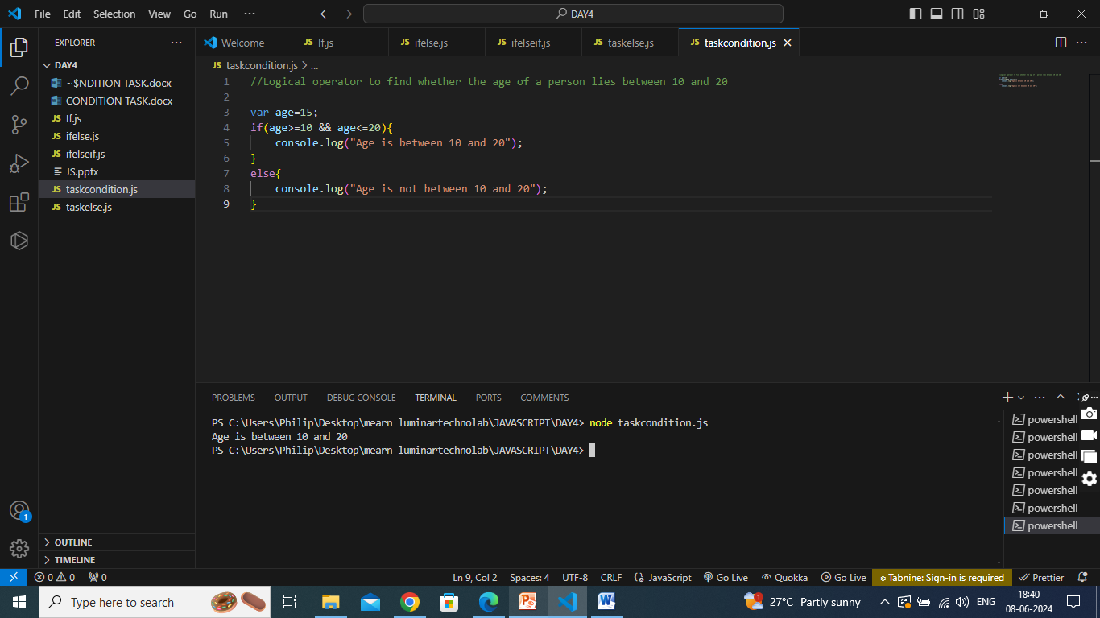

2. Demonstrate the use of switch case statements in js?

* Use the switch statement to select one of many code blocks to be executed.
* **Syntax :**

switch(expression) {  
   case x:  
     *// code block*     break;  
   case y:  
     *// code block*     break;

default:

// code block  
}

How switch statement works:

* The switch expression is evaluated once.
* The value of the expression is compared with the values of each case.
* If there is a match, the associated block of code is executed.
* If there is no match, the default code block is executed.

Example

The getDay() method returns the weekday as a number between 0 and 6.

(Sunday=0, Monday=1, Tuesday=2 ..)

This example uses the weekday number to calculate the weekday name:

switch (new Date().getDay()) {  
  case 0:  
    day = "Sunday";  
    break;  
  case 1:  
    day = "Monday";  
    break;  
  case 2:  
     day = "Tuesday";  
    break;  
  case 3:  
    day = "Wednesday";  
    break;  
  case 4:  
    day = "Thursday";  
    break;  
  case 5:  
    day = "Friday";  
    break;  
  case 6:  
    day = "Saturday";

**OUTPUT:** Saturday

1. Find whether a number is divisible by 2 and 3?

Logical AND

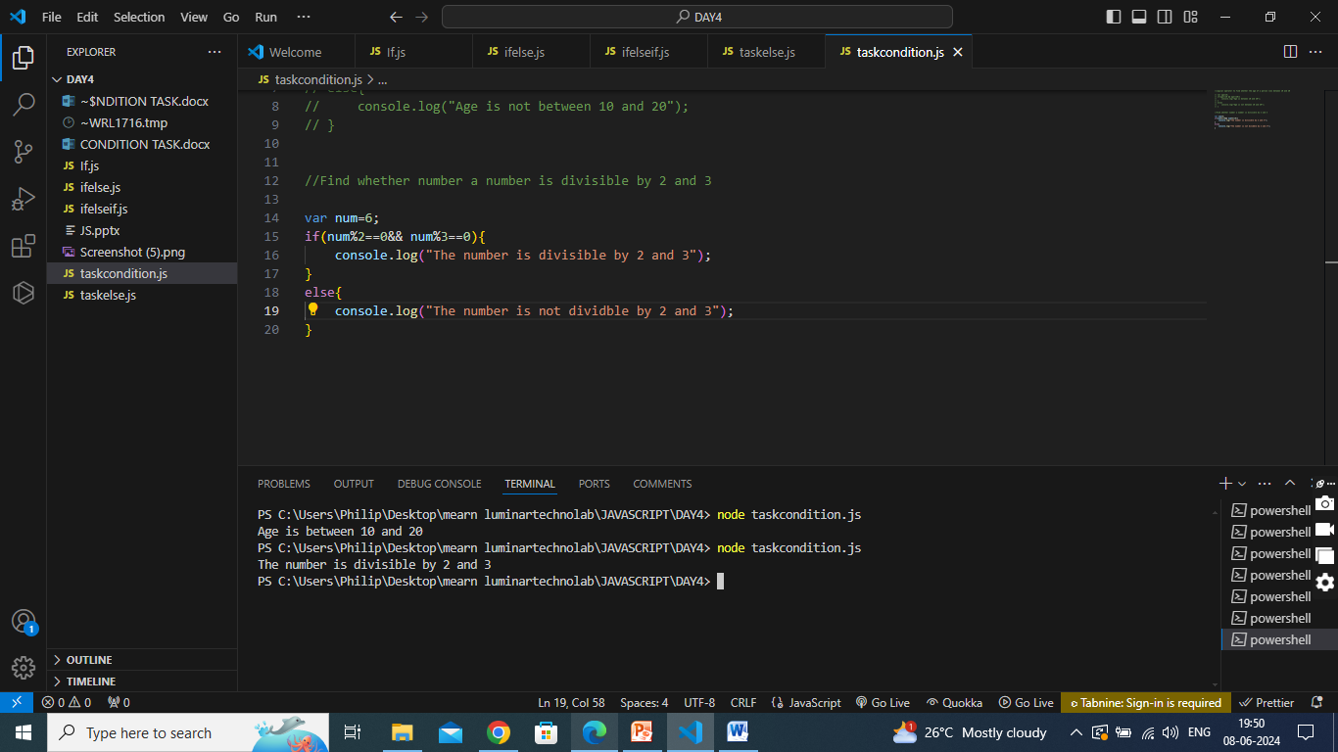

1. Find whether a number is divisible by either 2 or 3?

Logical OR

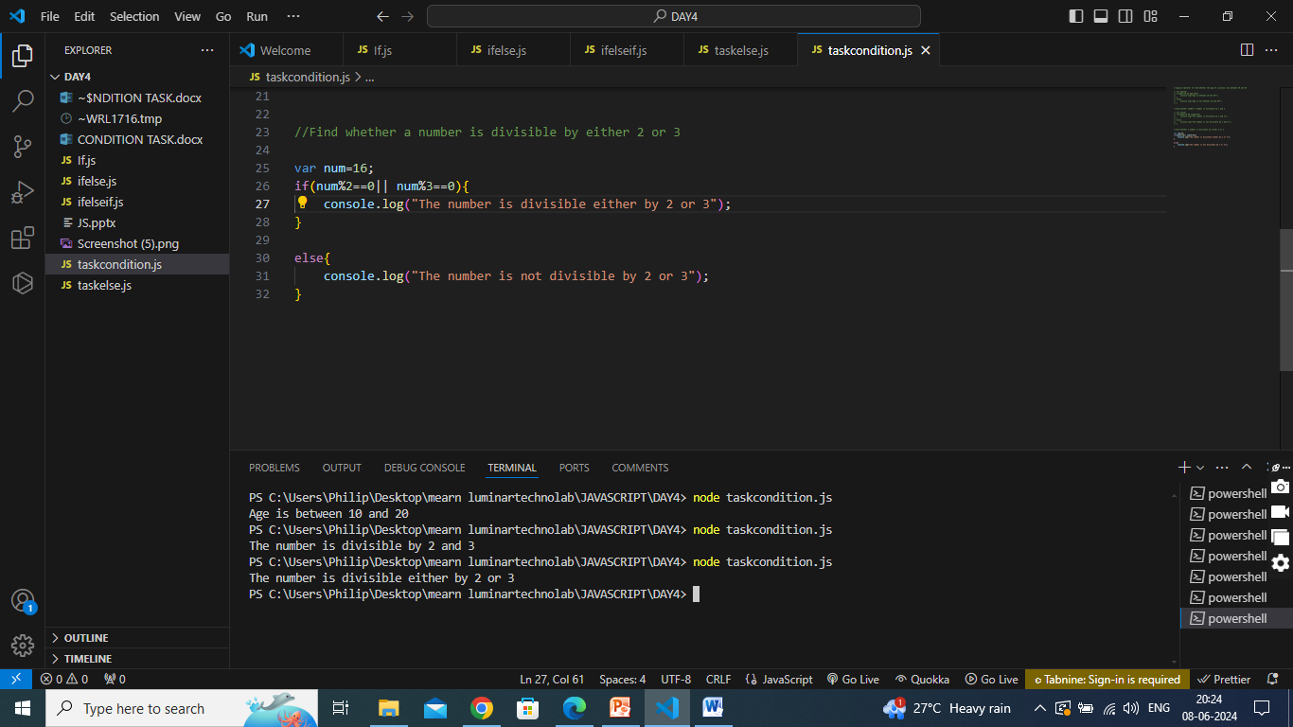

1. Print "You can Drive" or "You can't Drive" based on age being greater than 18 using ternary operator?

Using Turnary operator

